Design Specification

Oracle Consulting Services

IGS.Provisioning Service Model

Author: Dieter Steding
Creation: Date: 06/29/2023
Latest Update: 07/13/2023
Control Number: <Document Control Number>
Version: 1.0.0.0

Approval:

Document Control

Change Record
Date | Author | Version | Change Reference
06/29/23 | Dieter Steding | 1.0.0.0 |  | No previous document

Reviewer
Name | Position

Distribution
Copy No. | Name | Location
1 | Library Master | Project Library
2 |  | Project Manager
3
4
Table of Content
Document Control ii
Change Record ii
Reviewer ii
Distribution ii
Accountability iv
Provisioning Service Model v
Data Types v
Core Schema vi
Entity vi
Entitlement vii
Account vii
Application viii

Accountability
Participants accountability includes:
The participants are able to implement the dependencies of multiple IT systems necessary for account provisioning in order to obtain the extensive use of a specialist procedure. This requires the participant is familiar with the infrastructure components involved.
Ensuring that the data provided by the F-IAM are integrated in their timely correctness.
Any violation of the consistency and integrity of the data provided will inevitably result in the rejection of the user accounts affected, regardless of the interface used for delivery.
The participants are obliged to rectify errors themselves. Full support from the operational staff of the Federal Criminal Police Office is not provided.
For a participant who decides to independently control the provisioning of the user accounts through his IAM system, any rights to a further manual assignment of rights, roles or user accounts in the central F-IAM are withdrawn (view only principle; responsibility principle).

Provisioning Service Model
The Provisioning Service provides the API to trigger provisioning accounts to the target system. Therefore it is a facade on top of the core functionality Identity Manager already offers for this purpose.
The need to implement such a service arises from the distribution of the services across the participants that supply data for provisioning and the consistency and integrity of such data at the time of its delivery.
The main task of this service is therefore to protect the internal provisioning processes in Identity Manager from inconsistencies within the data delivery and to ensure the security requirements of the Federal Criminal Police Office with regard to the sensitivity of the data. At the same time, this service is responsible for communicating to the data sources provisioning orders that cannot be carried out for any reason.

Data Types
The entities declared within the schema underlying the Provisioning Service Model are based on a shared core schema.
META-INF/schema/xsd/core.xsd
This schema only defines the data types used.
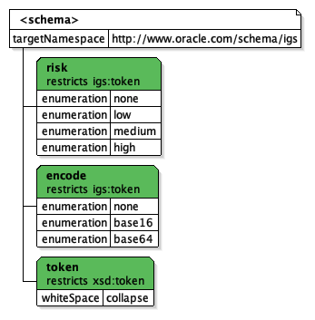

Element | Description
token | A token is a simple string with all whitespaces condensed. This means that all control characters are replaced with spaces and the resulting consecutive spaces are reduced to a single space.
encode
risk

Core Schema

Entity
META-INF/schema/xsd/entity.xsd
This schema only defines the abstract types.
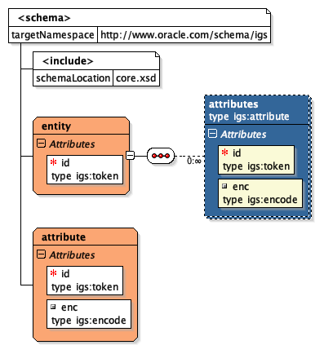

Element | Description
attribute | The complex type attribute represents a tagged-value pair. An attribute carries an id for naming purpose and encloses the value mapped at that id.  This complex type is abstract can only exists in an enclosing element.
entity | This complex type entity enclose the collection of generic attribute definitions.  The id attribute of this type is the public name derived from the Identity Manager configuration and intended to used for lookup any object deployed in Identity Manager by its name using the id as a matching criteria.

Entitlement

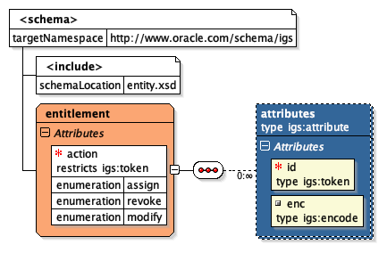

Element | Description
entitlement | The complex type entitlement declares the attribute action and enclose the collection of generic attribute definitions.  Attribute action on its own is an enumeration of the activities assign and revoke. Therefore it is possible to specify the activity how to handle an entitlement at the time of provisioning.

Account
The schema of a user account includes the generic description of the data model of a target system in Identity Manager.
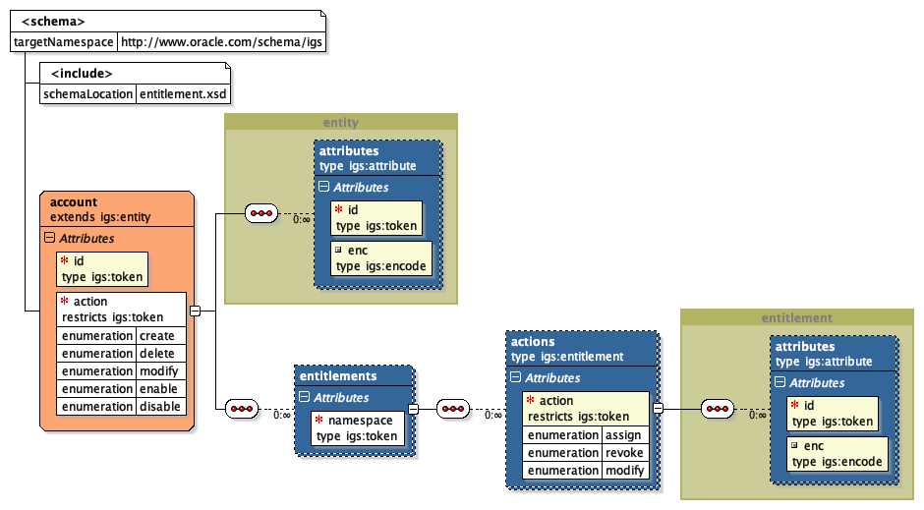

Element | Description
account | An account as a complex type inherits all from entity. The element entitlements of this type provides the collection of entitlements belonging to the account in the enclosing application to provision.  The type account is extended with the attribute action.  Attribute action on its own is an enumeration of the activities create, delete, modify, enable and disable. Therefore it is possible to specify the how to handle an account at the time of provisioning.  An account enclose element attributes as a complex type that inherits all from attribute and therefore enclose the collection of generic attribute definitions.
entitlements | The enclosed element entitlements of an account belongs to a specific namespace of entitlements (OIM Child Form).  The element entitlements is always surrounded by an element account.
actions | The enclosed element actions inherits all from entitlement and is extended with the attribute action.  Attribute action on its own is an enumeration of the activities assign and revoke. Therefore it is possible to specify the activity how to handle an entitlement at the time of provisioning.

Application
The service expects a provisioning request per application systems.
Any provisioning request is base on this schema
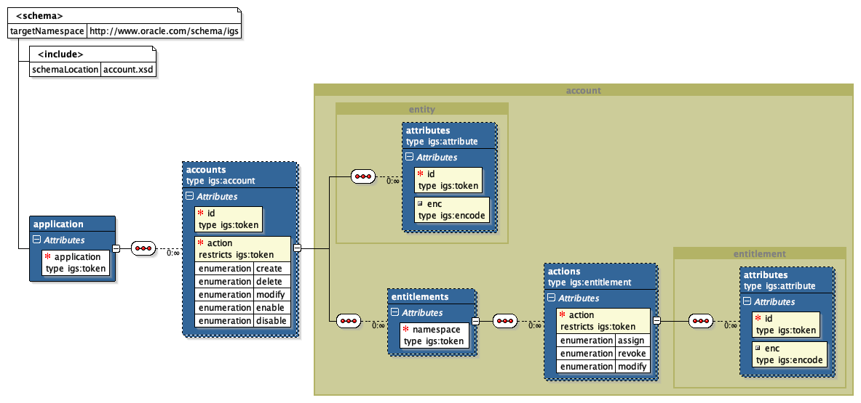

Element | Description
application | An application as a complex type defines the enclosing element to describe the provisioning actions on an account.  For that purpose it enclose an element accounts based on the complex type account that itself inherits from entity. The complex type account itself enclose the complex type entitlements. To be able to specify the activities how to handle the account embedded in an application at the time of provisioning the account is extended with an attribute action. This attribute represents the regular lifecycle activities applicable on an account and enumerates create, delete, modify, enable and disable. If action is unspecified its defaults to create.  For naming purpose the application provides an attribute id that refers to the application instance name which is per definition in Identity Manager a token without any whitespace.
accounts | An account as a complex type inherits all from entity. The element entitlements of this type provides the collection of entitlements belonging to the account in the application to provision.  The type account is extended with the attribute action.  Attribute action on its own is an enumeration of the activities assign, revoke, enable and disable. Therefore it is possible to specify the activity how to handle an account at the time of provisioning.  The complex type entitlements embedded in account inherits all from entity and represents the collection of entitlements that belongs to a specific type of entitlement (OIM Child Form).

